CHAPTER TWO
Early Years in Abadan
My Father, My Mother, and the World of My Childhood
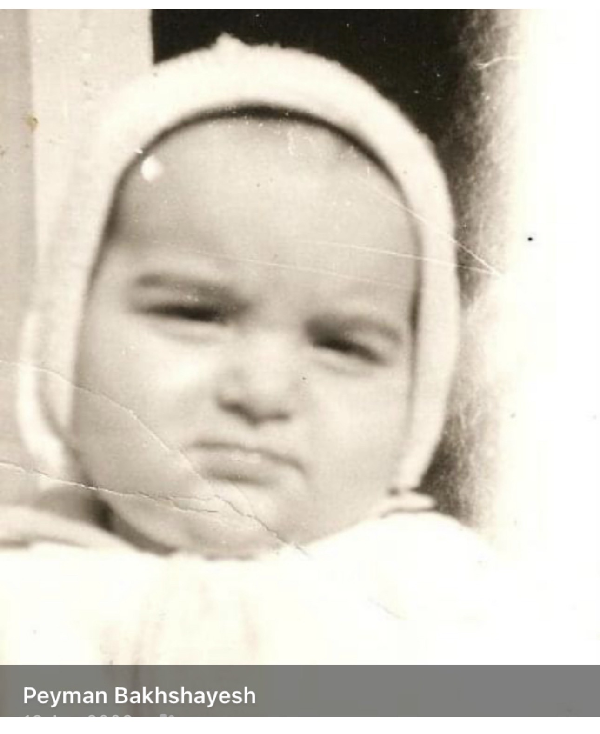
Me as a baby in Abadan. I was born on 19 September 1971.
I was born on 19 September 1971 in Abadan, the city in which the different journeys of my family had finally converged. According to my mother, I was born at home rather than in a hospital. My earliest story therefore begins not with an institution or an official record, but within the intimate world of a very young family.
My mother, Mahin, was born on 24 November 1954. She married my father in 1970, when she was only sixteen years old. By the time I was born the following year, she was seventeen - a young woman who suddenly found herself a wife and a mother.

My Father: From a Village near Golpayegan to the Imperial Iranian Navy
My father was born in 1947 into a farming family in the village of Mivan, near Golpayegan in Isfahan Province. His father was a farmer. The family included four sons - Hedayat, my father, Safar and the younger Mojtaba - and one daughter, Sakineh.
At about fourteen years of age, my father left his village and travelled to Tehran. It was the early 1960s, when Iranian society was changing rapidly and many rural families were moving towards expanding cities in search of work and opportunity. He found work in a textile factory in Shemiran No, in northeastern Tehran, where many people from the Golpayegan region had settled.
For a boy of fourteen, the transition from a farming village to industrial Tehran must have been immense. There was little room for a prolonged childhood. At fifteen, around 1962, he joined the armed forces and eventually served in the Imperial Iranian Navy.

America
Soon after joining the military, my father was sent to the United States for training, spending time in California, including San Diego and San Jose. For a teenager who had only recently left a small village in central Iran, America must have represented an extraordinary change of world. Within a remarkably short period, he had moved from rural Iran to Tehran, from a textile factory into military life, and then across the world to California.
He returned to Iran in 1969. In 1970 he married my mother, and in September 1971 I was born.

A Seventeen-Year-Old Mother
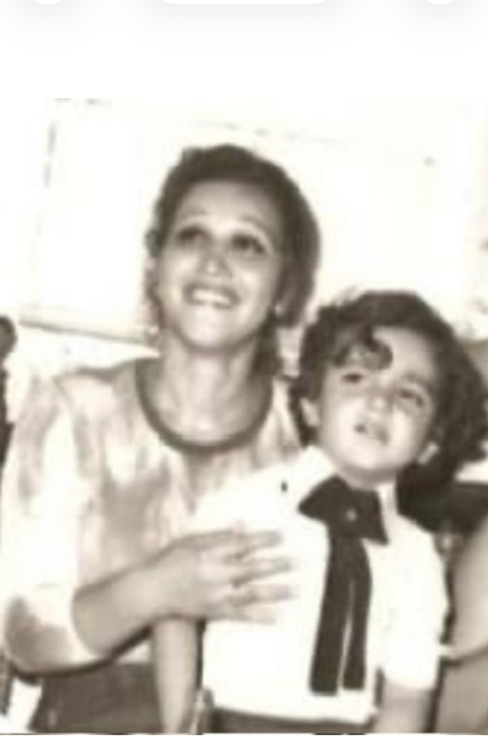
My mother, Mahin, with me during my early childhood in Abadan.
Only as an adult can I fully appreciate how young my mother was. At seventeen, she was caring for a newborn child while married to a young naval serviceman whose own adolescence had been shaped by leaving home, factory work, military discipline and life abroad.
As children, we imagine our parents as fully formed adults who have always existed in that role. Only decades later do we realise that they too were young people improvising their way through life. My mother had married at sixteen and became my mother at seventeen. Yet to me she was simply Mom - the fixed centre of my world.

My Father as I Remember Him
My memories of my father are complicated, as childhood memories often are. He was fundamentally a man who fought hard for his family. He wanted to provide for us, protect us and prepare us for life. He could also be temperamental. He sometimes went out with friends, drank beer and the strong Iranian spirit commonly called arak saghi, and at times his anger could become difficult to control.
As a small child, I remember arguments between my parents. I also remember occasions when my father hit my mother. My mother, however, was never simply passive. She resisted him and answered back, and at times the result was turmoil inside our home.
These are uncomfortable memories, but an autobiography should not make childhood more perfect than it was. Love and conflict can inhabit the same family. A person can possess generosity, courage and devotion while also carrying anger and weaknesses. That complexity was part of the reality in which I grew up.

There Is No Place for Weakness
Perhaps one of the strongest lessons my father passed on to me was his belief that life required toughness. His own childhood had taught him this early. He had left his village almost as a boy, worked in a factory, joined the military at fifteen, travelled to another continent for training, returned, married, become a father and assumed responsibility for a family.
He wanted us always to be alert, resilient and capable of defending ourselves. He believed that the world did not make much room for weakness. As a child, I could not fully understand where this philosophy came from. As an adult, I can: it came from his own life.

Abadan: The Landscape of Childhood
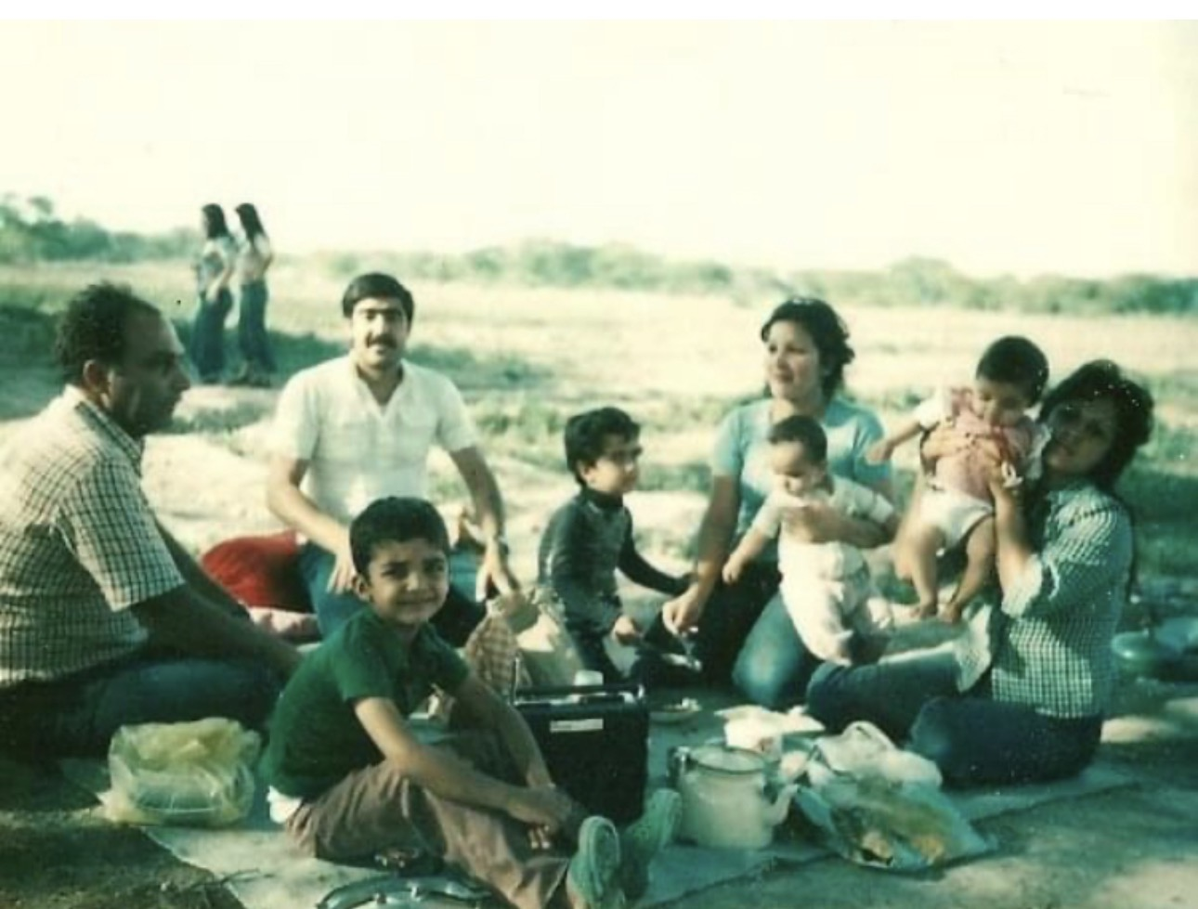
A family picnic during my childhood in Abadan: an ordinary family day that became part of the landscape of memory.
The Abadan of my childhood remains in my memory through fragments: heat, family gatherings, food, open spaces, friendships, adults talking, children playing and the sense of a city whose life revolved around the oil industry and the Persian Gulf.
One photograph captures a family picnic. Adults and children sit together outdoors with food, cooking pots and a radio on the ground. It is an ordinary scene, and perhaps precisely for that reason it is precious.
History books remember countries through monarchs, revolutions, wars and governments. Children remember them differently. We remember where we sat, who held us, the sound of adults talking while we played, the food we ate, the friends beside us, and a world that we assumed would always remain exactly as it was.

Anush and Aram
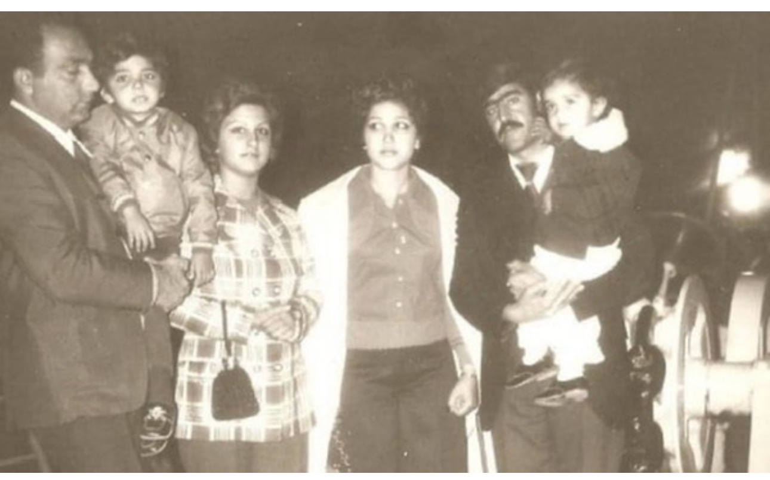
Our families together in Abadan. My father's close friend Anush and his son Aram were an important part of my childhood; Aram felt like a brother to me.
One of my father's closest friends was Anush. He had been born in Tehran and later came to work in Abadan. Our two families became close. Anush had a son named Aram, approximately one year older than me. From my earliest childhood, Aram became much more than simply the child of my father's friend. He became my best friend. In my childhood mind, he was almost a brother.
The photographs of our families together preserve that relationship. They capture a form of extended family that is not necessarily based on blood. When two families share enough meals, celebrations, worries and ordinary days, friendship itself becomes a kind of kinship.
Aram and I spent enormous amounts of time together. At that age, the distinctions adults make between relatives and friends mattered very little. What mattered was that he was there. We played together, grew together and inhabited the same small universe.

Before History Entered the Room
There is something particularly moving about photographs taken before catastrophe. Everyone in these pictures is living inside the present moment. Nobody knows what is coming.
The Iran of my earliest childhood was still the Iran of Mohammad Reza Shah Pahlavi. My father served in the Imperial Iranian Navy. Abadan remained one of the country's great industrial centres. Families worked, married, raised children, went on picnics and planned their futures.
For me there was no 'pre-revolutionary Iran.' There was simply home. Politics belonged to adults. My world consisted of my mother and father, relatives, family friends, Aram, games, meals and the streets and heat of Abadan.
Yet outside that child's world, Iran was changing. Within a few years, the monarchy under which my father had served would disappear. Revolution would transform the institutions of the country. Soon afterwards, Iran and Iraq would go to war, and Abadan - my birthplace, my mother's birthplace and the city that had brought our family together - would find itself directly on the front line.

The Child in the Photographs
When I look at the baby in the first photograph, or at the little boy beside his young mother, I experience the strange distance that everyone eventually feels from his own childhood. I know that child is me, but I also know things that he could never have imagined.
He does not know that the stable world around him will disappear. He does not know that revolution is approaching. He does not know that war will eventually drive his family from Abadan. He simply looks at the world around him.
Perhaps that is why these photographs matter so much to me. They are not merely records of what people looked like. They are evidence of a lost world - the Abadan of my childhood before revolution and war divided our lives into a before and an after.
My first chapter belonged to my grandparents and to the journeys that brought our family to Abadan. This second chapter belongs to my parents, my earliest friendships and my first memories.
It is the story of a teenage boy who left a village near Golpayegan, worked in a Tehran textile factory, joined the military and travelled to America before becoming my father. It is the story of a sixteen-year-old girl from Abadan who married him and became my mother at seventeen. It is the story of Anush and Aram, of friendship becoming family, of picnics and childhood companionship.
And it is the story of a little boy growing up in a hot oil city, surrounded by adults whose strengths and imperfections would leave permanent marks upon him. For a few more years, Abadan was simply home. Then Iran changed. And with it, my childhood changed forever.

