CHAPTER ONE
Before My Beginning
From Farahan and Mashhad to Abadan
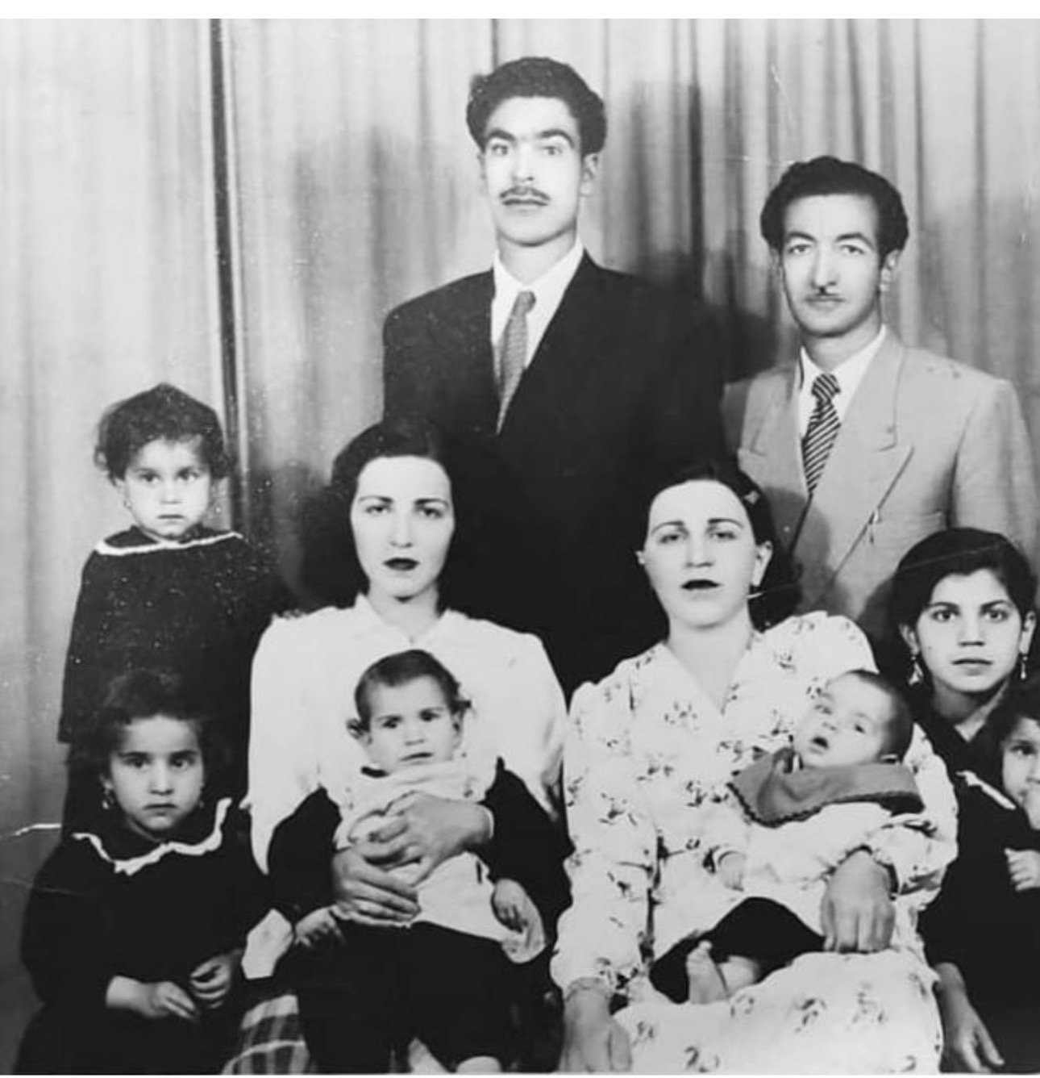
The family in Abadan, 1956. My mother, Mahin, was two years old.
Every life begins long before the day of birth. Mine began in the journeys, struggles, choices and ambitions of two families who came from very different parts of Iran and whose paths eventually converged in Abadan.
This old black-and-white photograph is, for me, more than a family portrait. Taken in Abadan in 1956, when my mother Mahin was only two years old, it preserves the first chapter of a story that had already travelled across Iran. Behind the still faces are journeys from Mashhad, Isfahan and Farahan; government service and military life; the upheavals of the Second World War; the rise of the oil city of Abadan; and, eventually, the family into which I would be born.

The Sharifian Family: From Mashhad Across Iran
Standing at the top right is Mr Sharifian, my maternal grandmother's father. He was born and raised in Mashhad, one of the great cities of northeastern Iran. He began his working life as a tax official and gradually advanced through the administrative system. His work required him to travel from city to city, helping to establish and organise tax offices across the country.
His career belonged to a period in which the Iranian state was extending its administrative reach and building institutions across a geographically vast country. His own life therefore became intertwined with the modernisation of Iran. During his travels he eventually married in Isfahan. His wife, my great-grandmother, is seated in the photograph holding their son, Gholam. Around her are members of the next generation, including her daughters Mansoureh and Mehri, the youngest daughter.

Abolhassan Farahani: From Farahan to the Army
Standing at the top left is my grandfather, Abolhassan Farahani. He was born and raised in Farahan, outside Arak in central Iran. His early life was shaped by a violent episode that permanently changed the direction of his future. His sister's husband was assassinated in a conflict involving people from another village. In the social world in which he lived, family honour and the fear of continuing intimidation carried enormous weight.
He was already married and had a young daughter, who is not present in this photograph. Faced with what he understood as a choice between retaliation and a lifetime of humiliation, he chose revenge. In the violence that followed, he killed men from the opposing village. The consequences were immediate: he could no longer remain safely in his home region, and he left Farahan.
Whatever judgment a later generation may make about such events, they belong to a particular historical and social environment. For my grandfather, that moment became the dividing line between one life and another.
He joined the military, entering the world of the Persian Cossack forces and later serving in the army during the rise of Reza Shah and the consolidation of the modern Iranian state. He was a physically imposing man, determined and courageous, and these qualities were valued in military life. His service was recognised and he gradually advanced in the army.
In 1941, history intervened again. During the Second World War, Britain and the Soviet Union invaded Iran. The Iranian armed forces were rapidly overwhelmed and Reza Shah was forced to abdicate. The military world in which my grandfather had built his new life was transformed. Once again, he had to begin again.

Abadan: Oil, Industry and a New Home
After leaving the army, Abolhassan came south to Abadan and began working in the oil industry associated with the British-controlled petroleum enterprise there. Abadan was unlike the rural world he had left behind. It was an industrial city, an international city and one of the most strategically important centres of the Middle East. Its refinery drew workers, technicians, administrators and families from every part of Iran.
His journey had taken him from Farahan, through violence and displacement, into military service and finally to the great oil city on the Shatt al-Arab. Abadan became the place where different branches of my family would converge.

The Women and Children in the Photograph
Seated in the photograph is my grandmother Patty, holding my aunt Shahin. My mother, Mahin, is also there, only two years old. Sitting in front and to the right is another of my aunts, Sedigh. Around them are the children of a family that had already travelled a remarkable distance, geographically and historically.
The photograph captures them before they could know what the following decades would bring. They could not foresee revolution, war, displacement or the scattering of Iranian families across cities and countries. At that moment they were simply a family gathered together in Abadan.

The City Where My Own Story Began
My mother's childhood was rooted in Abadan, and years later I too would be born there. Abadan was therefore more than my birthplace. It was the meeting point of several family journeys: one coming from Mashhad and Isfahan through the expanding institutions of the Iranian state, and another coming from Farahan through village conflict, military service, the upheavals of 1941 and employment in the oil industry.
I spent the first nine years of my life in Abadan. Then history entered our lives with overwhelming force. The Iran-Iraq War turned the city into a front line. The place where my grandparents had built their lives, where my mother had grown up and where I had spent my earliest childhood was transformed by war. We had to leave.
In a strange way, the pattern that had shaped my grandfather's life repeated itself in mine. He had been forced to leave Farahan when violence made remaining there impossible. Decades later, another form of violence - this time war between nations - forced our family to leave Abadan. The circumstances were completely different, but the human experience was familiar: home could suddenly become unsafe, and life could demand that one begin again somewhere else.
When I look at this photograph now, I see much more than my ancestors. I see migration and survival. I see the old village world of Farahan and the administrative world connecting Mashhad and Isfahan. I see the army, the upheaval of 1941, the oil industry and the rise of Abadan. I see mothers holding children who would themselves become mothers, and children whose lives would later be transformed by revolution and war.
Somewhere within this photograph, although I had not yet been born, my own story had already begun. The men and women in it carried their histories into the next generation. Their decisions, courage, mistakes, endurance and migrations created the circumstances into which I would eventually be born.
My life began in Abadan. But the road to my birth began much earlier - in Farahan, Mashhad and Isfahan; in government offices and military barracks; and finally beside the refinery and the waters of southwestern Iran.
This photograph is the first page of that story. When the Iran-Iraq War forced us to leave Abadan when I was nine years old, the second chapter of my life began.

