The Iranian Diaspora, Psychosocial Resilience, and Socioeconomic Achievement: A Critical Narrative Review
Prepared for Mr Peyman Bakhshayesh, MD, PhD, MBA
Date: 23 May 2026

Abstract
This paper reviews the available literature on Iranian diaspora mental health, acculturation, resilience, education, and socioeconomic outcomes. The central question is whether Iranian immigrants and their descendants can be characterised as economically and educationally successful but psychosocially vulnerable when compared with other immigrant-origin populations such as Indians, Chinese, Arabs/MENA groups, Latin Americans/South Americans, and Africans. The evidence supports a cautious, qualified version of this thesis: Iranians in the United States are highly educated and, in earlier U.S. data, had higher median household income than all immigrants and U.S.-born households. However, they are not uniquely superior on socioeconomic indicators: Indian immigrants, and some African and Chinese subgroups, outperform Iranians on several measures. Mental-health evidence suggests significant vulnerability among Iranian migrants, especially where migration was forced, politically traumatic, socially isolating, or associated with underemployment and acculturation stress. Yet there is insufficient head-to-head, harmonised evidence to conclude that Iranians are globally less psychosocially resilient than Arabs, Indians, Chinese, Latin Americans, or Africans. The more defensible conclusion is that the Iranian diaspora shows a high human-capital / high-psychological-burden profile: strong education and professional capital coexist with displacement trauma, identity rupture, family separation, political grief, status loss, and barriers to culturally sensitive mental health care.

Key conclusion
The statement that Iranians are doing economically and scientifically well while doing psychologically badly is directionally plausible, but it should not be stated as a universal or comparative fact without qualification. The strongest scientific formulation is: Iranian diaspora populations in Western countries often show high educational and professional achievement alongside clinically important mental-health and acculturation stressors; current evidence is inadequate to rank Iranian psychosocial resilience against all major immigrant groups.

1. Scope and method
This is a narrative scoping review rather than a formal meta-analysis. It synthesises peer-reviewed reviews and cohort/cross-sectional findings on Iranian immigrant mental health, publicly accessible demographic analyses from the Migration Policy Institute and Pew Research Center, and broad migration mental-health evidence from WHO and systematic reviews. Because countries use different definitions, instruments, sampling frames, and ethnic categories, numerical comparisons are presented as indicative rather than definitive.

2. Conceptual framework: resilience is not only economic success
Psychosocial resilience should be separated from socioeconomic success. A migrant group may have high education, high income, strong professional representation, and high civic participation while still carrying a high burden of anxiety, depression, post-traumatic stress, family separation, intergenerational grief, substance misuse, suicidal ideation, or identity conflict. Resilience therefore has at least four domains:
Domain | Core indicators | Iranian diaspora relevance | Interpretation
Economic resilience | Income, employment, poverty, asset accumulation | Strong in several U.S. datasets; mixed by destination country and migration cohort | High in selected contexts, but not universally exceptional
Educational/scientific resilience | Bachelor/graduate degrees, STEM presence, professional status | Very high among Iranian Americans and many Iranian migrants in Europe/North America | One of the clearest strengths
Psychological resilience | Depression, anxiety, PTSD, psychosis, suicide, substance misuse, help-seeking | Evidence of acculturative stress, adjustment problems, trauma exposure, and culturally specific barriers to care | Clinically important vulnerability
Social/cultural resilience | Language, integration, intermarriage, civic participation, social networks | Urban concentration and strong ethnic networks coexist with exile identity and political fragmentation | Ambivalent: protective and stressful at the same time

3. Size and migration history of the Iranian diaspora
The Iranian diaspora is numerically significant but difficult to measure precisely because official datasets often separate birthplace, ancestry, citizenship, race/ethnicity, and parental origin. Pew Research Center estimated about 750,000 Iranian Americans in 2024 and noted rapid growth after the Islamic Revolution and Iran-Iraq War. The same Pew analysis estimated 445,000 Iran-born immigrants in the United States, about one-quarter of approximately 1.7 million Iranian immigrants worldwide. The Migration Observatory at Oxford reported about 114,000 Iranian-born residents in the UK at the 2021/22 census and noted that Iran was the most common nationality among UK asylum applicants across 2016-2025. These data support the broad claim that post-1979 migration has been historically consequential, but the often-cited figure of “10 million exiles” should be treated as a political or expansive diaspora estimate unless a clear statistical definition and source are specified.

4. Socioeconomic and scientific achievement
The strongest quantitative evidence for Iranian diaspora success comes from the United States. Migration Policy Institute data for 2019 showed that 59% of Iran-born adults aged 25 or older had a bachelor degree or higher, compared with 33% of both U.S.-born and overall immigrant adults. Iranian immigrant households had a median income of $79,000 in 2019, compared with $64,000 for all immigrant households and $66,000 for U.S.-born households. Pew’s 2024 analysis of Iranian Americans as a broader origin group found that 65% had a bachelor degree or higher and about 35% had an advanced degree.
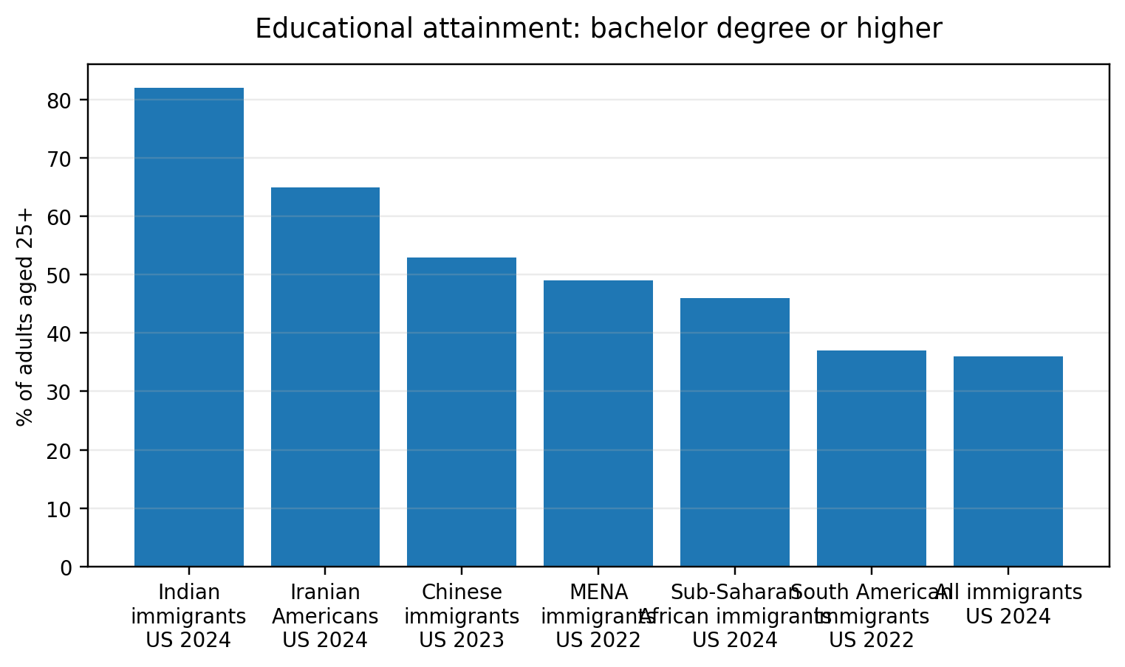
Figure 1. Educational attainment across selected U.S. immigrant-origin groups. Data years differ; Iranian figure is for Iranian Americans rather than strictly Iran-born immigrants.
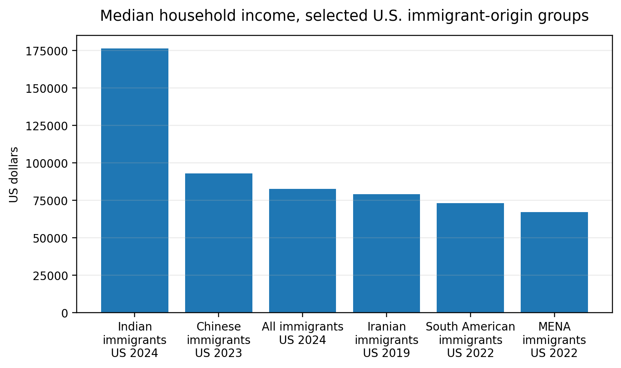
Figure 2. Median household income across selected U.S. immigrant groups. Not all data are from the same year; Iranian data are from MPI 2019 and should not be over-interpreted against 2022-2024 values.
The comparative picture is therefore mixed rather than triumphalist. Indian immigrants in the United States outperformed Iranians on available educational and income indicators in the most recent MPI data, with 82% having at least a bachelor degree and median household income above $176,000 in 2024. Chinese immigrants also had high educational attainment and median household income. Sub-Saharan African immigrants are highly heterogeneous: 46% had a bachelor degree or higher in 2024, with Nigerians, South Africans, Kenyans, and Cameroonians showing particularly high attainment. South American immigrants were closer to the overall immigrant average. MENA immigrants as an aggregate were highly educated but had lower median household income and higher poverty, reflecting the heterogeneity of Arab and non-Arab MENA origins.
Group | Country/data frame | Year | Bachelor+ (%) | Median household income | Interpretive note
Iranian Americans | U.S.; broad origin category | 2024 | 65 | Not reported in Pew short read | Very high education; broader than immigrant-only category
Iran-born immigrants | U.S.; MPI | 2019 | 59 | $79,000 | Higher than all immigrants and U.S.-born in 2019
Indian immigrants | U.S.; MPI | 2024 | 82 | $176,200 | Clearly exceeds Iranian 2019 income and Iranian-American education
Chinese immigrants | U.S.; MPI | 2023 | 53 | $92,800 | High income and education; lower bachelor+ than Iranian Americans, higher than Iran-born 2019 unclear by year
MENA immigrants | U.S.; MPI | 2022 | 49 | $67,000 | Highly heterogeneous; income lower than all immigrants
Sub-Saharan African immigrants | U.S.; MPI | 2024 | 46 | Group median not given in lines used; selected countries range $46,800-$120,800 | High heterogeneity; South Africans/Kenyans high-income
South American immigrants | U.S.; MPI | 2022 | 37 | $73,000 | Near all-immigrant education; slightly below all-immigrant income

5. Mental health, acculturation, and psychosocial burden
The mental-health literature on Iranian immigrants is smaller and less harmonised than the socioeconomic literature. A 2021 review of Iranian immigrants and descendants found only 17 post-2010 studies meeting criteria, mostly focused on stress, adjustment, depression, and culturally sensitive treatment. It identified acculturation stress, cultural flexibility, religious identification, social/economic support, and physical health as relevant factors. This means the field is not yet mature enough to support a precise global ranking of Iranian resilience against other immigrant groups.
Nevertheless, several findings support concern. A classic Canadian study reported that 60% of Iranian immigrants in its sample met criteria for adjustment disorder with depressed or anxious mood. A later review of Iranian migrant health reported that approximately 28% of Iranian immigrants in Germany were suffering from untreated mental disorders. These are important signals but should not be treated as population-wide prevalence estimates for all Iranians abroad because samples, instruments, and recruitment methods differ. In broader migration research, Lindert and colleagues found pooled depression prevalence of 20% among labour migrants and 44% among refugees, and pooled anxiety prevalence of 21% among labour migrants and 40% among refugees. WHO similarly notes that depression, anxiety, PTSD, suicide, and psychosis can be more prevalent among refugees and migrants than host populations, especially when cumulative social disadvantage is present.
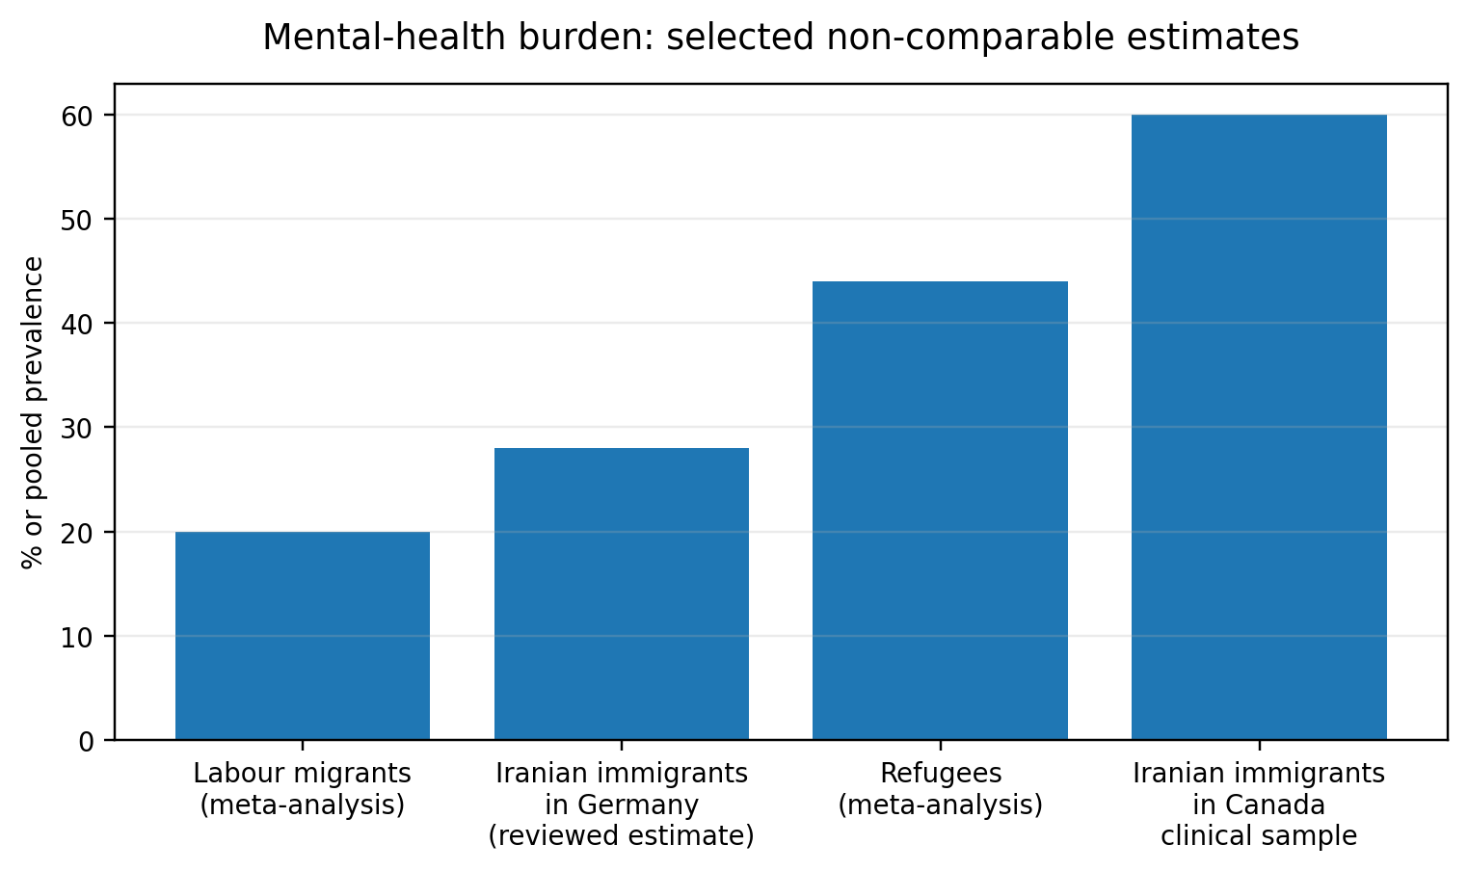
Figure 3. Mental-health burden estimates are deliberately shown as non-comparable signals, not as a formal ranking. The Canadian Iranian estimate was from a specific clinical/settlement-era sample; global labour/refugee values are pooled meta-analytic estimates.

6. Why high achievement can coexist with psychological vulnerability

6.1 Forced migration and political exile
A substantial part of Iranian migration after 1979 was linked to revolution, war, political repression, religious/minority persecution, economic collapse, sanctions, and professional constraint. Forced or semi-forced migration differs psychologically from voluntary career migration: it is more likely to involve grief, survivor guilt, fear for relatives, status loss, political anger, and unresolved identity conflict.

6.2 Status inconsistency and professional loss
Many Iranian migrants arrive with high education, but host-country credential recognition may be slow. A surgeon, engineer, academic, lawyer, or civil servant may temporarily become economically secure but professionally humiliated. This “status inconsistency” is a recognised migration stressor and may be particularly salient in educated diasporas.

6.3 Acculturation stress
Migration psychology consistently shows that integration tends to be healthier than marginalisation or separation. A systematic review on acculturation strategies found that marginalisation was linked to worse depression symptoms and that integration was associated with the least depressive symptoms; marginalisation more than tripled anxiety-related symptoms compared with integration.

6.4 Political grief and digital proximity
Modern diasporas do not simply leave the homeland. Satellite television, Telegram, Instagram, X/Twitter, WhatsApp, and Persian-language media maintain continuous emotional exposure to executions, protests, war, sanctions, repression, and family distress. The result is a form of transnational chronic stress: the body is in London, Toronto, Los Angeles, Berlin, Stockholm, or Sydney, but the nervous system remains attached to Tehran, Shiraz, Mashhad, Tabriz, Ahvaz, Kurdistan, Baluchistan, and the political fate of Iran.

6.5 Cultural identity and family proximity
Iranian society historically placed high value on family proximity, intergenerational obligation, language, food, ritual, and dense social life. Migration can therefore produce not only economic displacement but also relational displacement. The loss is not only “country” but neighbourhood, extended kinship, mother tongue in public life, social recognition, and spontaneous belonging.

7. Can we conclude that Iranians are psychosocially weak but economically/scientifically strong?
A scientifically careful answer is: partially, but not in the absolute comparative form. The evidence supports the following graded conclusions:
Claim | Evidence status | Best wording
Iranians in Western diaspora are highly educated. | Strong for the U.S.; plausible but destination-specific elsewhere. | Iranian Americans and Iran-born U.S. immigrants show high educational attainment; similar patterns appear in several Western diaspora settings, but should be specified by country.
Iranians are economically successful. | Moderate to strong in U.S. data; mixed by destination, cohort, gender, and legal status. | Iranian immigrants in the U.S. had higher median household income than all immigrants in 2019, but Indians and some other groups outperform them.
Iranians are scientifically/professionally successful. | Plausible, supported indirectly by education and occupation data; needs discipline-specific measures. | The diaspora contains high levels of human capital and professional representation, especially in management, business, science, arts, medicine, engineering, academia, and entrepreneurship.
Iranians are psychologically doing badly. | Moderate evidence of vulnerability; not enough for universal prevalence claim. | There is clinically important evidence of depression, anxiety, adjustment problems, trauma-related stress, and acculturative stress among Iranian migrants.
Iranians are less psychosocially resilient than Arabs, Indians, Chinese, Latin Americans, and Africans. | Not established. | No robust harmonised cross-group evidence supports a global ranking. Group comparisons require matched sampling by age, sex, legal status, migration pathway, class, time since arrival, language, and host country.

8. A more accurate model: “high human capital, high exile burden”
The Iranian diaspora is best understood through a dual-axis model. On the vertical axis is human capital: education, professional knowledge, scientific productivity, entrepreneurship, and political literacy. On the horizontal axis is exile burden: trauma, grief, family rupture, loss of homeland, mistrust, factional politics, acculturation stress, and unresolved identity conflict. Iranians can score high on both axes. This is not a contradiction; it is a central feature of elite and middle-class political exile.
Profile | Human capital | Exile burden
Protected integration | High | Low to moderate: strong language, stable status, social support, meaningful work
High-achieving wounded exile | High | High: trauma, family separation, political grief, underemployment, identity conflict
Marginalised migrant | Low to moderate | High: insecure legal status, language barrier, poverty, social isolation
Assimilated second generation | Moderate to high | Variable: identity conflict may persist despite educational success

9. Implications for community leadership and mental health policy
- Use culturally competent mental-health services that understand Iranian political trauma, secular/religious diversity, family honour, shame, somatisation, and mistrust of institutions.
- Avoid romanticising success: high income and high education do not protect fully against depression, anxiety, PTSD, substance misuse, or suicide risk.
- Support integration rather than isolation. The evidence on acculturation suggests that integration is psychologically healthier than marginalisation or rigid separation.
- Recognise intergenerational effects: children of exiles may inherit political grief and identity tension even when they perform well educationally.
- Build diaspora institutions that combine civic participation, mental-health literacy, professional networking, language/cultural continuity, and bridges into host societies.
- For political movements, reduce factional hostility: traumatised diasporas are vulnerable to splitting, idealisation, conspiracy thinking, and moral absolutism. Institutions should encourage disciplined debate and psychological safety.

10. Limitations of the evidence
The major limitation is comparability. “Iranian,” “Persian,” “MENA,” “Arab,” “South Asian,” “Chinese,” “African,” “Latin American,” “refugee,” “asylum seeker,” and “immigrant” are not equivalent categories. Mental-health studies use different instruments and recruitment methods; socioeconomic datasets use different years and definitions. The paper therefore does not rank immigrant groups by resilience. It identifies a plausible pattern and the evidence needed to test it rigorously.

11. Proposed future study design
A rigorous answer would require a matched multi-country cohort study. It should compare Iranian, Arab/MENA, Indian, Chinese, Latin American, Caribbean, and African-origin migrants in the same destination countries, using the same instruments and controlling for age, sex, education, legal status, refugee/asylum pathway, income, time since arrival, language proficiency, discrimination, social support, and premigration trauma.
Component | Recommended measure | Reason | Outcome
Mental health | PHQ-9, GAD-7, PCL-5, CAGE-AID, psychosis screen | Standardised comparison | Depression, anxiety, PTSD, substance misuse, psychosis risk
Resilience | Connor-Davidson Resilience Scale; social support scale | Separates coping capacity from symptoms | Protective factors
Socioeconomic status | Income, occupation, credential recognition, poverty, wealth | Distinguishes education from actual labour-market outcome | Economic integration
Acculturation | Language proficiency, identity, integration/separation/marginalisation | Tests mechanisms | Cultural adaptation
Transnational stress | Family in origin country, media exposure, political trauma | Highly relevant for Iranians | Exile burden

12. Final conclusion
The Iranian diaspora should not be described simply as “successful” or “damaged.” It is better described as a high-human-capital diaspora marked by the psychological consequences of abrupt historical rupture. Compared with many immigrant populations, Iranians in the United States are highly educated and relatively economically successful, although Indians and selected other groups outperform them on several measures. Psychologically, the literature shows meaningful vulnerability associated with acculturation stress, forced migration, trauma, social isolation, underemployment, and culturally specific barriers to care. The scientifically defensible conclusion is not that Iranians are uniquely non-resilient, but that Iranian resilience has often been expressed through education, work, entrepreneurship, and political mobilisation while psychological suffering remains under-recognised and undertreated.

References
Amini, B., Raheel, O., Exum, A. and Fazzino, T.L. (2021/2022). Mental Health of Iranian Immigrants and Their Descendants: A Review. Professional Psychology: Research and Practice, 53(2), 192-204. DOI: 10.1037/pro0000434.
Bagheri, A. (1992). Psychiatric problems among Iranian immigrants in Canada. Canadian Journal of Psychiatry. PubMed PMID: 1551048.
Batalova, J. and colleagues, Migration Policy Institute. Immigrants from Iran in the United States. Migration Information Source, 15 July 2021.
Choy, B., Arunachalam, K., Saurman, E., et al. (2021). Systematic review: Acculturation strategies and their impact on the mental health of migrant populations. Public Health in Practice, 2, 100069.
Lindert, J., von Ehrenstein, O.S., Priebe, S., Mielck, A. and Brähler, E. (2009). Depression and anxiety in labor migrants and refugees: A systematic review and meta-analysis. Social Science & Medicine, 69(2), 246-257.
Migration Observatory, University of Oxford. Iranian migration to the UK in 7 charts. 10 March 2026.
Migration Policy Institute. Indian Immigrants in the United States. Migration Information Source, 15 April 2026.
Migration Policy Institute. Chinese Immigrants in the United States. Migration Information Source, 15 January 2025.
Migration Policy Institute. Middle Eastern and North African Immigrants in the United States. Migration Information Source, 12 June 2024.
Migration Policy Institute. South American Immigrants in the United States. Migration Information Source, 11 April 2024.
Migration Policy Institute. Sub-Saharan African Immigrants in the United States. Migration Information Source, 16 October 2025.
Pew Research Center. 7 facts about Iranians in the U.S. 5 March 2026.
Shishehgar, S., Gholizadeh, L., DiGiacomo, M. and Davidson, P.M. (2015). The impact of migration on the health status of Iranians: An integrative literature review. BMC International Health and Human Rights, 15, 20.
Turrini, G. et al. (2017). Common mental disorders in asylum seekers and refugees: Umbrella review of prevalence and intervention studies. International Journal of Mental Health Systems, 11, 51.
World Health Organization. Mental health of refugees and migrants: risk and protective factors and access to care. Global Evidence Review on Health and Migration series, 2023; WHO Refugee and migrant mental health fact sheet, 2025.

Appendix: data notes for figures
Figure 1 uses bachelor-degree-or-higher shares from Pew/MPI sources. Iranian Americans 2024 = 65%; Indian immigrants 2024 = 82%; Chinese immigrants 2023 = 53%; MENA immigrants 2022 = 49%; Sub-Saharan African immigrants 2024 = 46%; South American immigrants 2022 = 37%; all immigrants 2024 = 36%.
Figure 2 uses median household income from MPI sources. Years differ and should not be interpreted as a strict league table. Iranian immigrant income is from 2019; Indian and all-immigrant comparison values are from 2024; Chinese is 2023; South American and MENA are 2022.
Figure 3 intentionally mixes non-comparable estimates to illustrate burden signals only: labour migrants/refugees from Lindert et al. meta-analysis; Iranian Canada estimate from Bagheri; German untreated mental-disorder estimate as reported in Shishehgar et al. review.

